**CIS-21A-45405 Linux Operating System Administration**

**Final Project**

For my final project I will install from scratch Linux Mint with 2 hard drives (one for the local system and one for the user data), format and configure the second hard drive for users to store /home folder data, configure all users /home folder to second hard drive in fstab, add user accounts to group with folder permissions. The second hard drive is to avoid local system contention if the hard drive get full with user data; all users’ home folders will be on the 2nd hard drive.

1. **Installing Linux from scratch with two separate hard drives:**

* Configured the new virtual machine in virtual environment

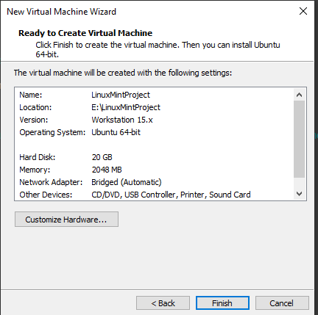

* Ready to click Finish and boot from ISO. Next step is to install Linux from ISO.

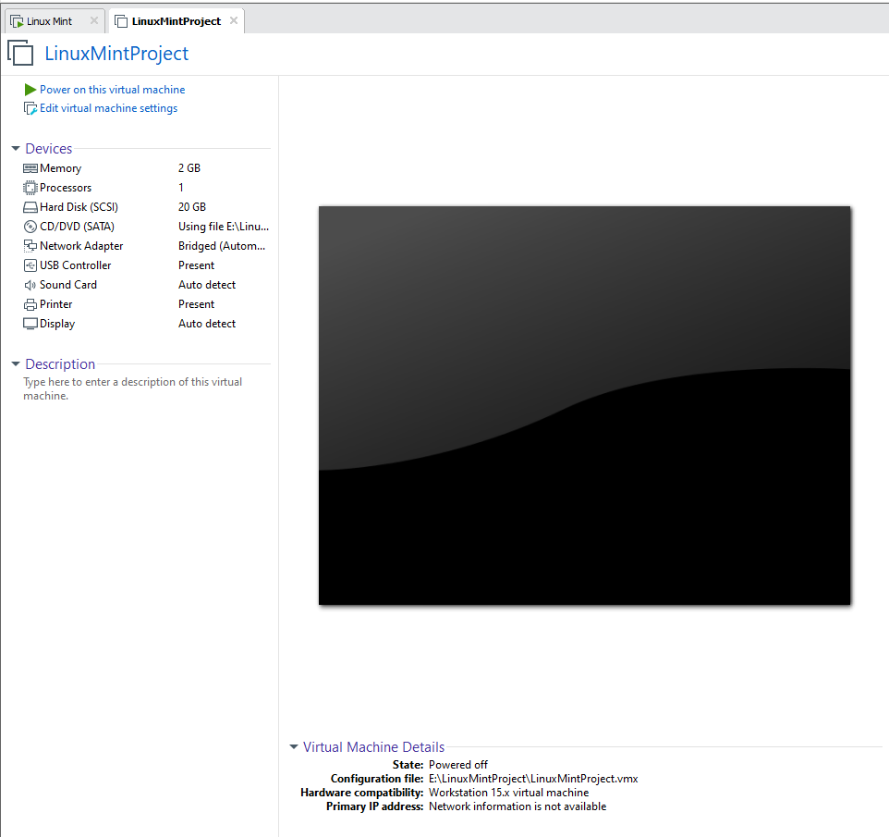

* New system booted from ISO file in VMware workstation. Installing from ISO.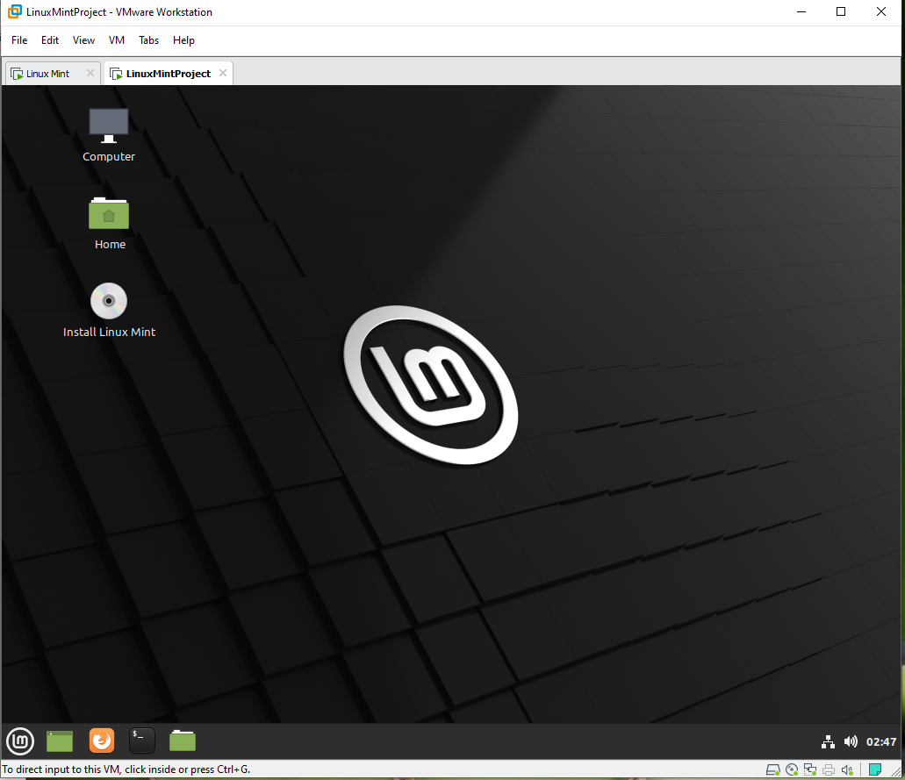
* Ready to erase temporary disk and make installation permanent.

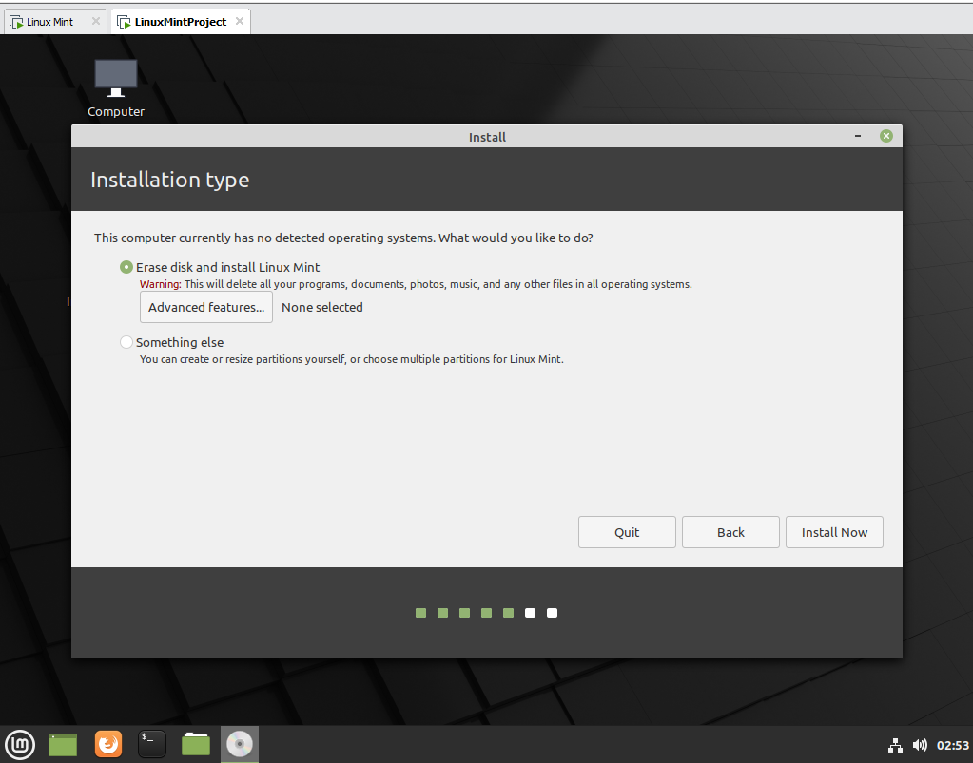

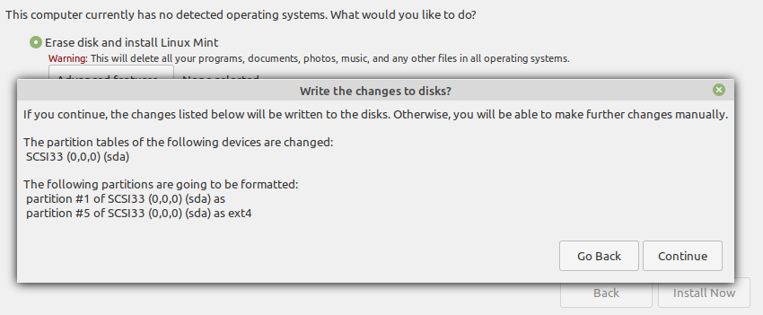

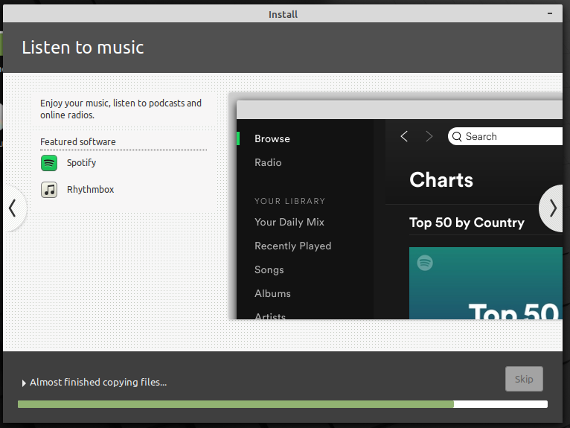

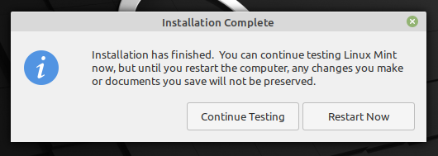

1. **Adding second hard drive for user data in virtual environment and configuring inside of Linux for future user usage.**

5 GB hard disk added to virtual environment for user data.

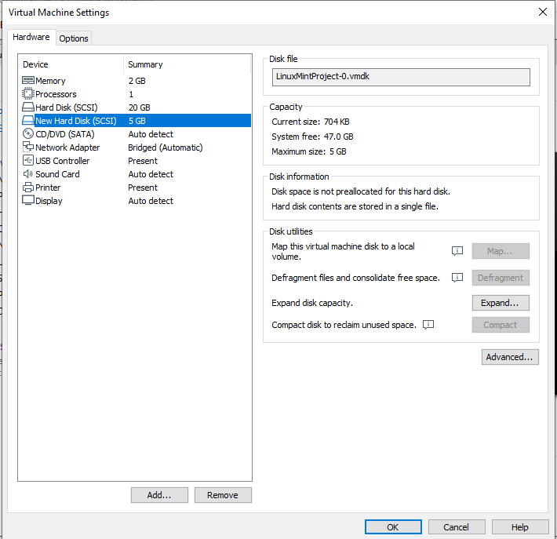

**Formatting second disk with ext4 file system and mounting it to the local system.**

Display the available hard drives, partitions and size.

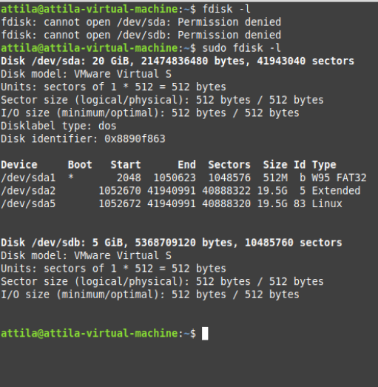

Using fdisk to manage the 5GB hard drive.

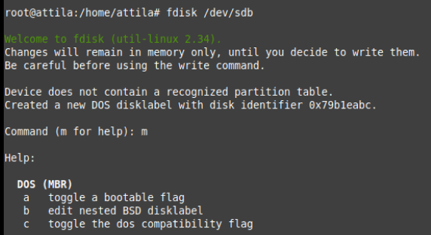

Create Linux primary partition of 5GB.

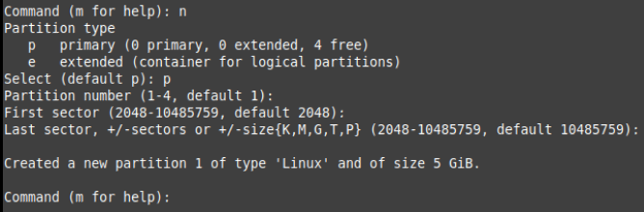

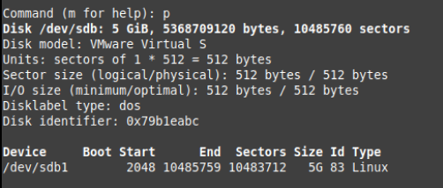

Save configuration:

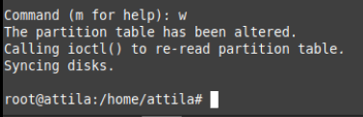

Create an ext4 filesystem

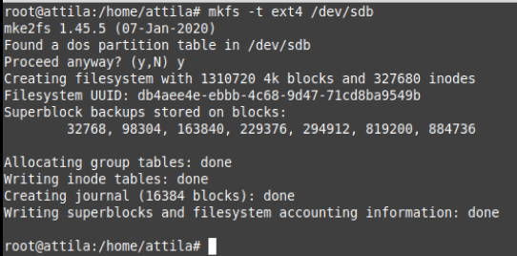

Mounting second hard drive to the home directory:



1. **Display /etc/fstab (already modified) to automatically mount the hard drive after reboot:**

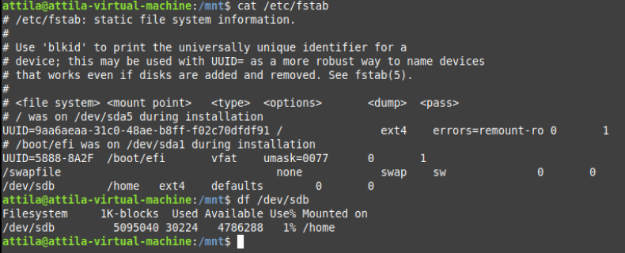

Also show the primary hard drive and secondary hard drive mount:

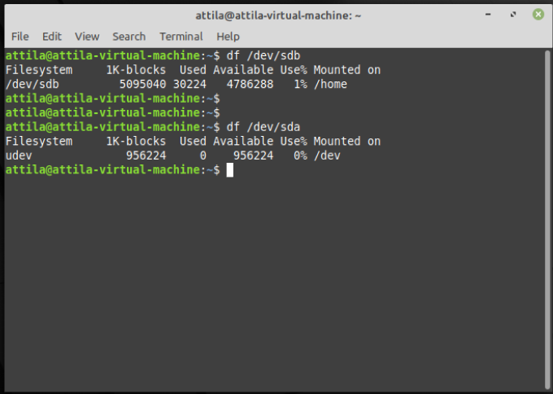

1. **Adding user/group Joe, add/delete group NetworkUsers and setting permissions on files in folder /opt for Attila and Joe.**

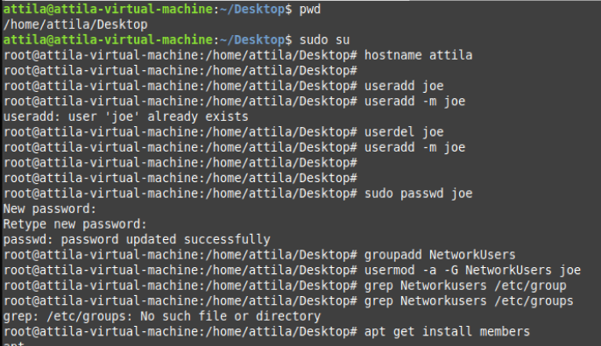

Confirming membership for ‘joe’ in the NetworkUsers group:

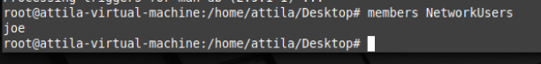

Creating files in the /opt folder for each user with permissions:

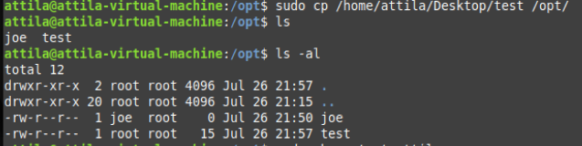

Changed owner for file test to Attila (previously root (see above image)):

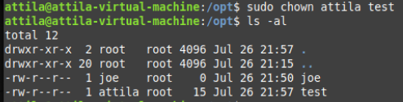

Renamed files in /opt folder for ease of permissions setting:

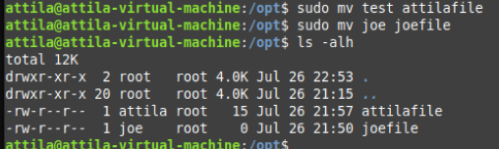

Modified file under /opt for user joe:

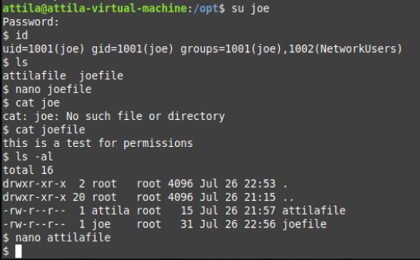

File attilafile does not have permissions under user ‘joe’ to be modified.

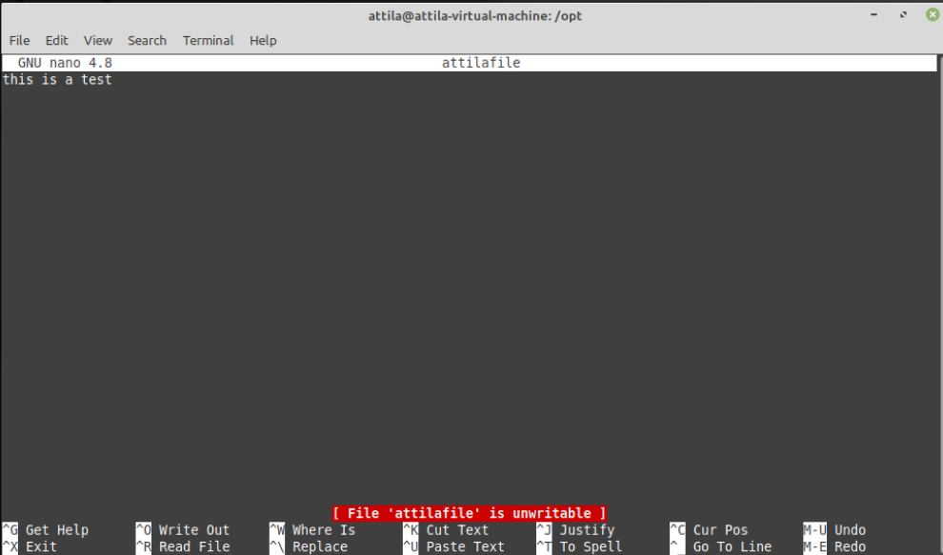

Showcasing Joe’s group assign:

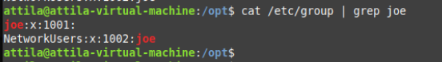

Deleted group NetworkUsers:



Changed file group ownership:

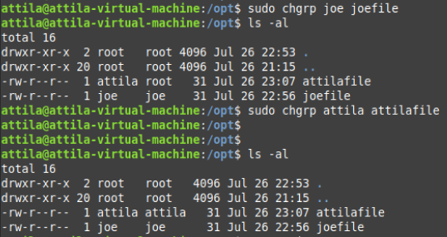

Changed the file ownership for joefile and attilafile files:

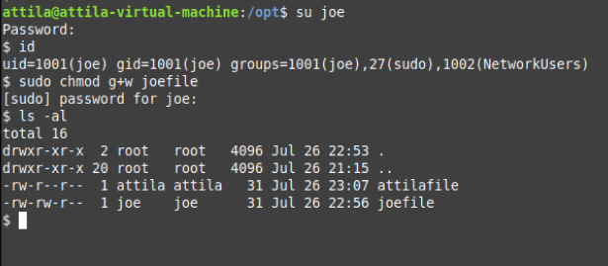

Changed permissions for group to ‘write’ for file attilafile:

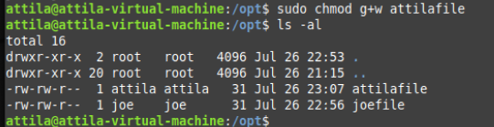

1. **Verifying file permissions:**

Tried to modify joefile logged on as Attila:

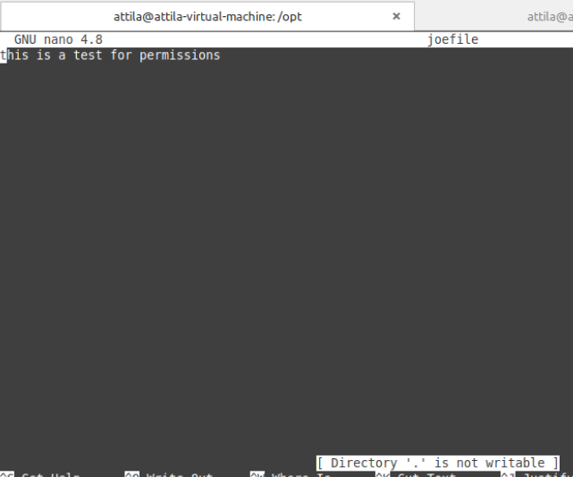

Tried to modify attilafile logged on as joe:

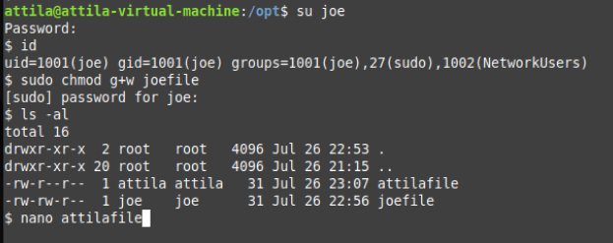

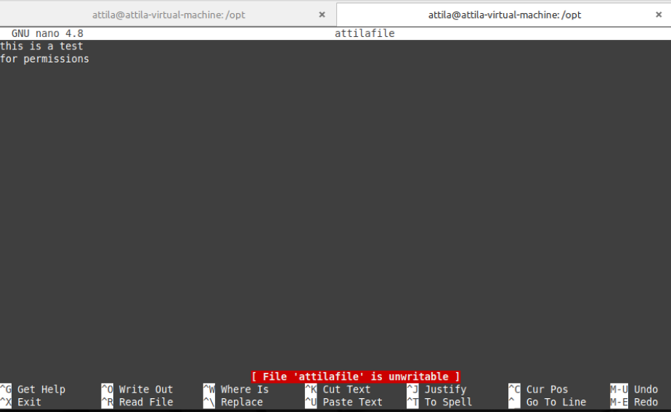

Removed Others group permissions to read other users’ files. Second ‘cat’ command issued after permissions changed.

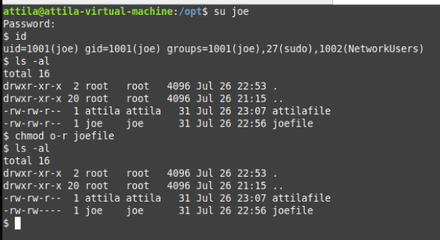

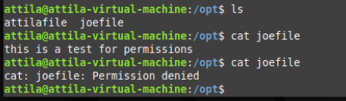

Modified group permissions to allow group users full permissions on their files:

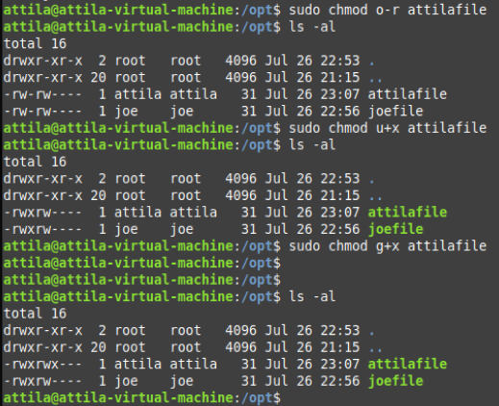

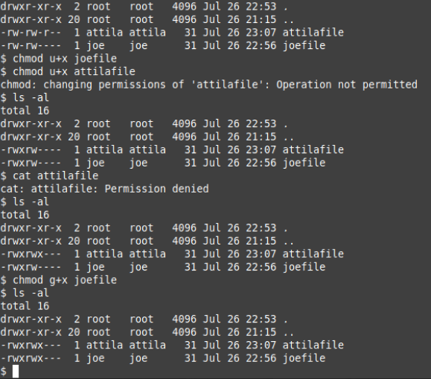

Logged on to system as Joe to attempt to modify /opt file attilafile:

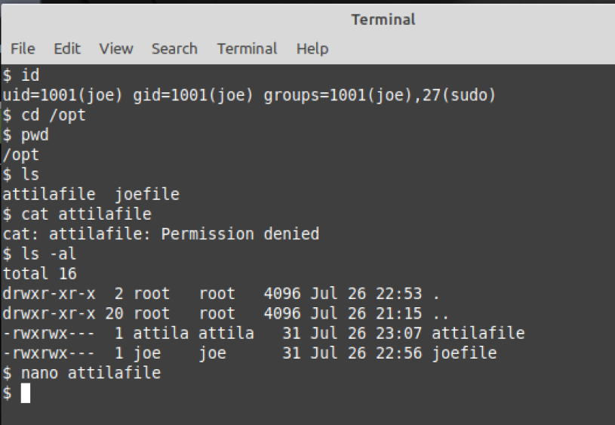

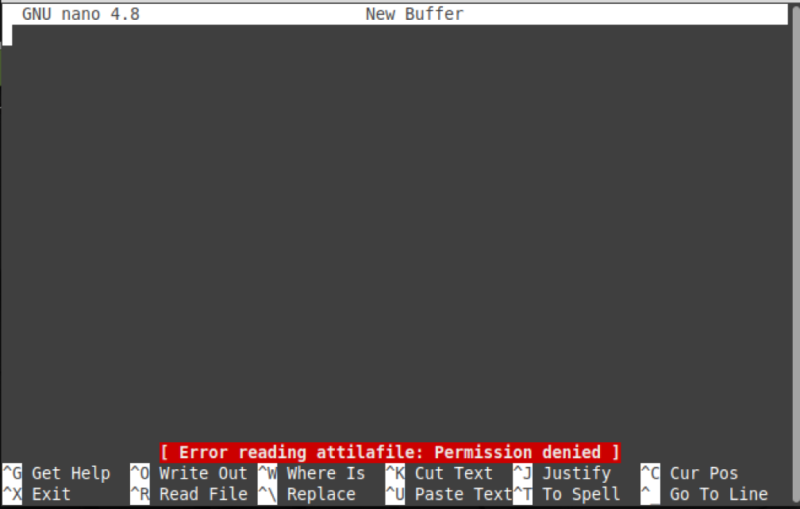

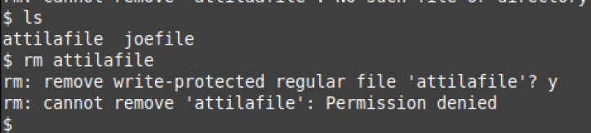

Logged on to system as attila to attempt to modify /opt file joefile:

